[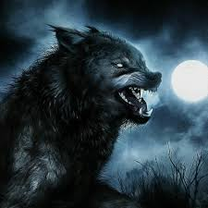](https://www.google.com/url?sa=i&rct=j&q=&esrc=s&source=imgres&cd=&cad=rja&uact=8&ved=2ahUKEwib9diYxN_fAhWFl-AKHXFBDw4QjRx6BAgBEAU&url=https://www.facebook.com/Werewolvespage/&psig=AOvVaw0Xry9GOkqIrVwukG8N0N2d&ust=1547083205596993)Are people really Werewolves during the Full Moon?

# Datasets

## Moon Phases/Astronomical Dataset

<https://www.aerisweather.com/support/docs/api/reference/endpoints/sunmoon-moonphases/>

2015-2017 data for all datasets

## City Crime Data – Cities

* Minneapolis – Dave
  + http://opendata.minneapolismn.gov/
* San Francisco – Katie
  + https://data.sfgov.org/Public-Safety/Police-Department-Incident-Reports-Historical-2003/tmnf-yvry
* Denver – Erin
  + https://www.denvergov.org/opendata/dataset/city-and-county-of-denver-crime
* Houston – Ricky
  + <http://data.houstontx.gov/dataset/houston-police-department-crime-statistics>
* Miami - Sammeh
  + https://miami.demo.socrata.com/Government/Miami-Crime/fjex-3twp
* Justin

## Questions to Answer

* Is there a correlation between moon phases and crime
* Is there a correlation between moon phases and specific types of crime (murder/violent crimes)
* Which types of crime are committed most during a full moon
* Which types of crimes are committed the most during the month

*Alternative Hypothesis: If werewolves are real then more crimes will have been committed during periods of a full moon over the period of 2015-2017.

*If werewolves are not real, than the crime rate over the same time period will be the same or lower during the full moon.